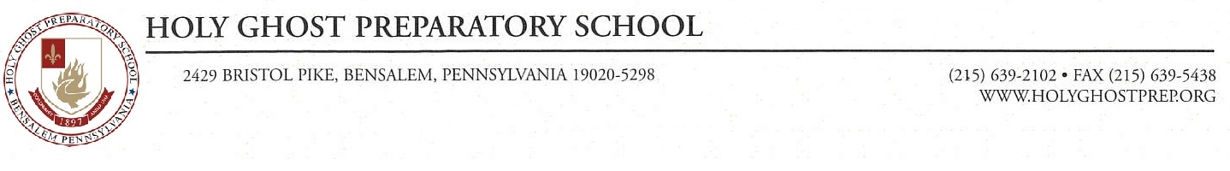

**Printing at HGP**

The Holy Ghost Prep printing system allows every student to print from his mobile device. The system uses a Google Cloud Printer to send pages from your device to the copy machines. Here are the steps that you can follow if you want to print from your device at HGP.

1. You must use your “holyghostprep.org” email address or have your Gmail account registered with the school and you must have Google Chrome installed on your computer.
2. [Click here](https://www.google.com/cloudprint/addpublicprinter.html?printerid=10c8d9ad-461f-3fc0-2104-295696e71dc7&key=259013166) and click “Add Printer”. This will add the printer to your Gmail account.

https://www.google.com/cloudprint/addpublicprinter.html?printerid=10c8d9ad-461f-3fc0-2104-295696e71dc7&key=259013166

1. Install the “Google Cloud Printer” Driver by following the instructions here: <https://tools.google.com/dlpage/cloudprintdriver>
2. When you print, choose **HolyGhostMFPs** or **Google Cloud Printer** as the printer. If you choose **Google Cloud Printer**, Chrome will open and you will have to select the **HolyGhostMFPs** from there. The pages will be sent to the printer, but will not print until you login to the copy machine by waving your Access Card in front of the card reader. There is a color machine in the Library and a black and white machine in F301.
3. Each student receives $2.00 per semester for printing. A black and white (Monochrome) page costs $0.01 and a color page costs $0.05 so make sure you choose monochrome unless you need color. If you wish to purchase more printing, please see Mr. Jacobs. The money on your Aramark account is **NOT** related to the money on the copiers.
4. Anything that is printed to these machines will be stored for 24 hours in the queue and will be removed after that. You can print from home and the pickup your paper once you get to school as long as it is within 24 hours.
5. Please make sure that you logout of the copier when you are finished.

If you have any questions or difficulties, please see Mr. Jacobs in F301 or Mrs. Joganich in

C224.